Women’s Forum of Colorado Panel Discussion
Program: International Human Rights for Women
Speakers:
Cynda Collins Arsenault, Phyllis Cox, Patricia Foley Hinnen, Melissa Theesen, and Eliza Woloson
Panelists and Moderator:
Cynda Collins Arsenault, Co-Founder and Board Member of One Earth Future and the Arsenault Family Foundation. Founder of Our Secure Future – Women Make the Difference and Women Powering Change. She is President of Secure World Foundation, promoting cooperative solutions for the secure and sustainable use of outer space for the benefit of humanity. She has 45+ years of experience in non-profit work including peace and justice, criminal justice, mental health, disability rights and environmental issues.

Phyllis Cox has over 40 years of experience, first in the practice of law in Colorado, and then in law and development work overseas, focusing particularly on rule of law, human rights, legal and judicial reform, access to justice and legal aid, especially for women and children, anti-corruption, capacity building, access to justice and legal aid. She has worked in a broad range of countries and cultures, e.g. Afghanistan, Philippines, Bangladesh, Cambodia, Democratic Republic of Congo, Cote d’Ivoire, Liberia, Haiti and Guyana. She has taught law at the university level in Turkey and in Cambodia.

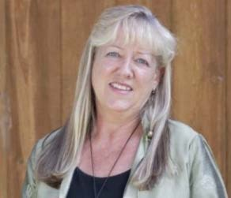
Patricia Foley Hinnen is Founding CEO of Capital Sisters International, a non- profit that finances women’s micro loans in developing countries (https://www.capitalsisters.org/) . She worked in international development for the US Congress and State Department before establishing Capital Sisters where she has financed tens of thousands of women’s micro businesses in 25 countries. As a Microfinance Advisor to the State Department, she represented the U.S. in the 21-nation Asia Pacific Economic Cooperation forum for a decade as head of the Women Leaders Network. Patricia is highly awarded including receiving Global Purpose Prize for Financial Inclusion (Encore/AARP).

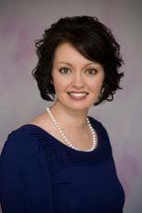
Melissa Theesen, is the Managing Director at ECDC African Community Center which works to help refugees and immigrants rebuild safe, sustainable lives in Denver (http://www.acc- den.org). She has professional experience across four continents and has been a member of several Boards of Directors for local nonprofit organizations. She also has extensive experience in Asian, African, and Latin American communities. She has worked in Guatemala, Mexico, Tanzania, Kenya, Rwanda, Uganda, India, Nepal, and Cambodia. Her professional experience includes refugee resettlement, grant writing, leading fundraising campaigns, acting as a liaison for governmental programming transitions, social business development, volunteer management, managing individuals from multiple cultures, managing multiple stakeholder groups, and consulting with the United Nations.
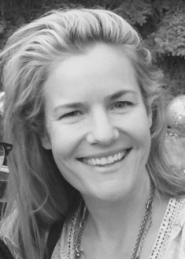
Eliza Woloson, Anthropologist, Entrepreneur. In 1997, after her anthropological research in Sumbawa, Eliza founded Global Education Fund, a non-profit that invests in transformative local solutions to education in developing countries. In 2012, Eliza co-Founded Women Have Wings, a human rights award made possible from the selling of Amelia Earhart's sister-ship Electra 10-E (http://www.womenhavewings.org/). A Delegate for the United Nations Commission on the Status of Women, Eliza was most recently involved with the passing of Senate Bill 196 making it possible for people with intellectual disabilities to be included on college campuses in Colorado. She has received numerous awards for her work.

